## Prepare your music in MATLAB

1. Run “music2GRwave.m” in MATLAB after setting correct .mp3 file name

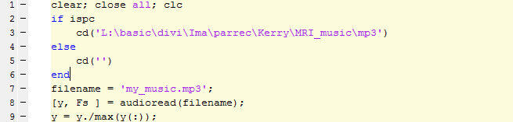

1. Find the generated **my_music.dat** and copy it to the scanner console computer

## Play your music on the MRI scanner

1. Select the “MRI_Music” patch
2. Copy your “my_music.dat” file to “G:\Patch\” and rename as “**MRI_Music.dat**”
3. Load the “Music Resonance Instrument” examcard

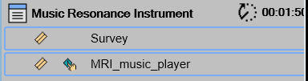

1. Perform the Survey scan normally
2. Set “**M.R.I. (Music Resonance Instrument)**” to “**YES**” to enable the function
3. Set “Loop Music” to “YES” if you want to loop music if the scan duration is longer than the music

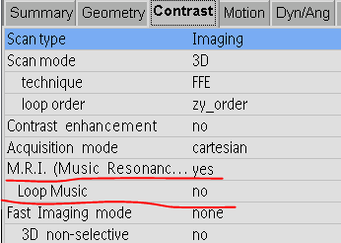

1. Change parameters (“dynamic number”, “NSA”, FOV, resolution etc. ) to adjust the scan time (music play time) based on your music length. Do **NOT** change
   1. the TR, which should be fixed at 4 ms to match the hardcoded sequence.
   2. the sequence type, which should be FFE
2. Start scan and enjoy